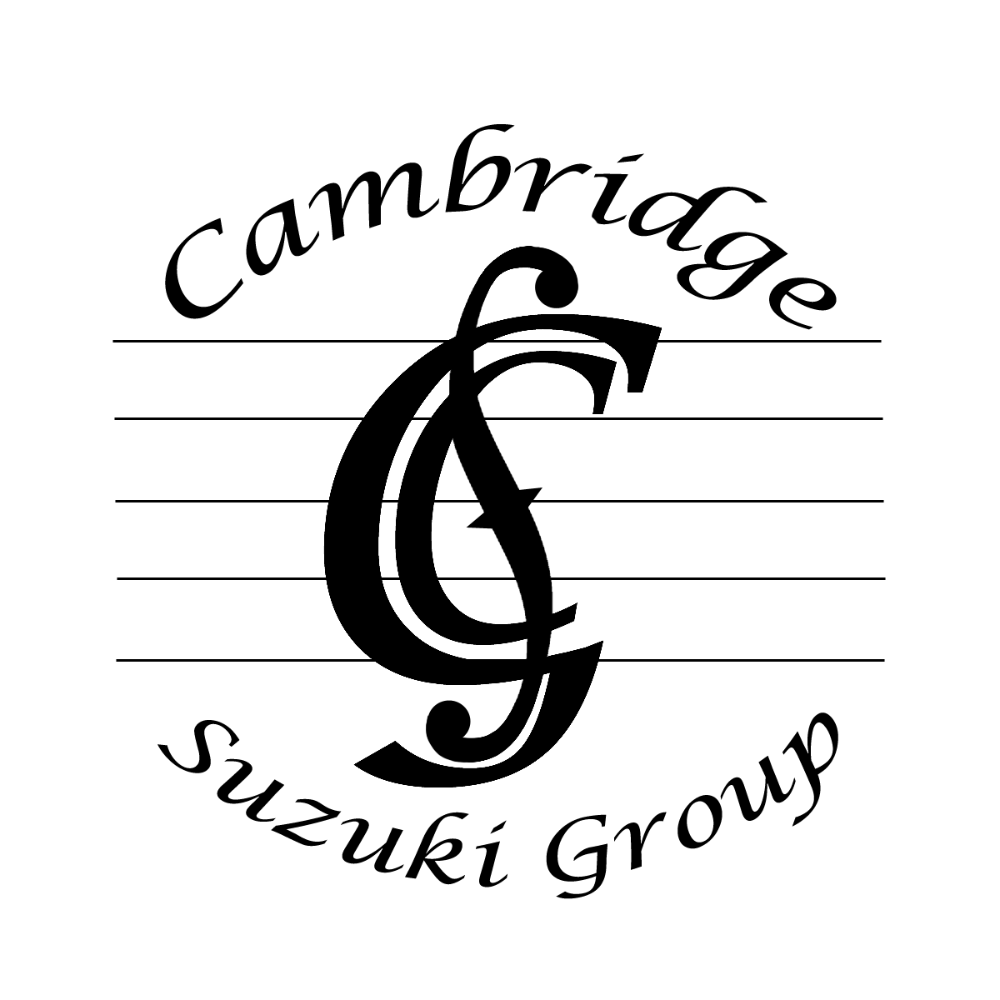

Concert

Given by piano pupils of Jenny Macmillan

St Luke’s Church

Victoria Road, Cambridge, CB4 3DZ

3.00 pm Sunday 24 November 2024

Izabela Baranauskaite (11) Sonatina in G 2nd mov Beethoven
Melody Schumann

Anthony Subin (4) Go tell Aunt Rhody Folk song
London Bridge English folk song

Ming Deng (7) Ecossaise Hummel
Happy Farmer Schumann

Annabelle Daly (9) Minuet 1 in G min Bach
Minuet 3 in G Bach

Adele Baranauskaite (12) Sonata in G Op49 No2 2nd mov Beethoven
Sweet Dreams Tchaikovsky

Mei Deng (4) Piccadilly Circus Suzuki
Lightly Row German folk song

Liana Zurcher (5) French Children’s Song French folk song
Twinkle, twinkle, little star Folk song

Jamie Tang (9) Ecossaise Beethoven
Sonatina in C Op55 No 1 1st mov Kuhlau

Charles Tang (11) Sonatina in C Op55 No 1 2nd mov Kuhlau
Little Waltz Gurlitt

Fedor Ustinov (13) Invention in F Bach
Venetian Gondola Song Mendelssohn

Keyi Lu (6) Allegretto 1 Czerny
Go tell Aunt Rhody Folk song

Benji Daly (6) Chant Arabe Anon
Cuckoo German folk song

Daniel Subin (7) Minuet 1 in G Bach
Short Story Lichner

Emily McMillan (16) Prelude in B min Chopin
Waltz in A min Chopin

Ziyan Lu (9) Minuet 2 in G min Bach
Sonatina in C Op55 No1 1st mov Kuhlau

Toby Parker (11) Sonatina in C Op55 No1 2nd mov Kuhlau

Qiao Wang (12) Sonatina in C Op36 No1 Clementi
2nd and 3rd movs

Matteo Nacher Saltara (16) Oiseaux Tristes from Miroirs Ravel

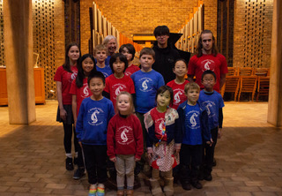

Jenny and pupils after Autumn term concert 2023

